
Symbiosis Institute of Technology, Pune
Faculty of Engineering
CSE- Academic Year 2026-27
Java Programming – Lab Batch 2024-28
Lab Assignment No:-13
Name of Student: Sanika Botre
PRN No.: 25070122063
Batch: 2025-29
Class: CSE A-2
Academic Year & Semester: 2026 2nd Semester
Date of Submission:
Title of Assignment: Write a Java program to perform reading from and writing to a file using file handling operations.

Learning Objectives: To perform file reading and writing operations using Java file handling classes.

Theory :
Java provides file handling through the java.io package. Classes such as File, FileReader, FileWriter, BufferedReader, and BufferedWriter are used to perform input and output operations. File handling enables permanent storage and retrieval of application data. Proper exception handling is necessary to manage file-related errors. These concepts are essential for data persistence.

Practice questions:
- Create a program to write and read employee details from a file.
Code:
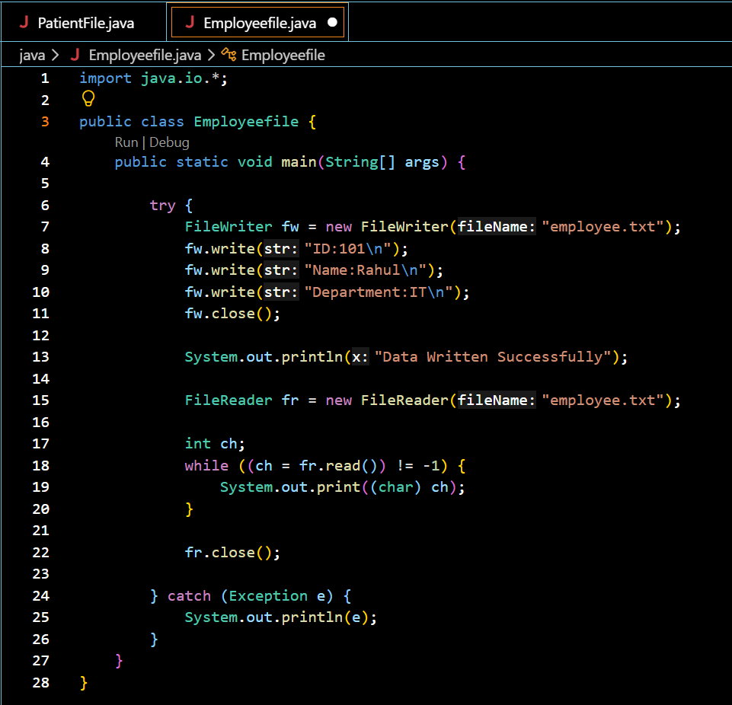

Output Screenshots:
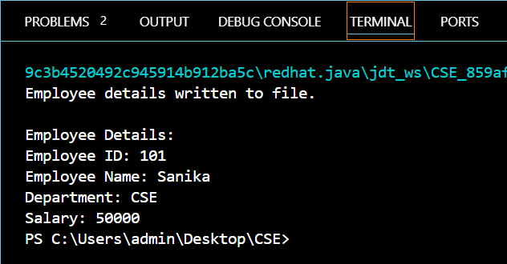

- Create a Java program to write patient details (patient ID, name, age, and diagnosis) to a file and read the details from the file for display.
Code:
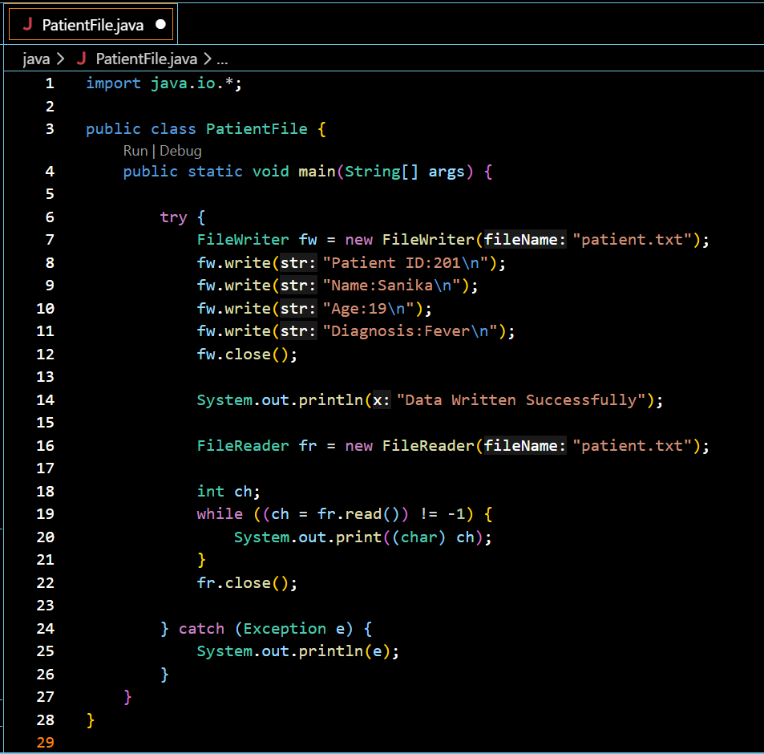

Output Screenshot:
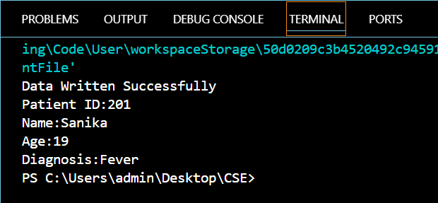

Conclusion:
This program demonstrates Java file handling by writing data to a file and reading it back successfully. It uses the FileWriter and FileReader classes to perform input and output operations, showing how data can be stored permanently and retrieved whenever needed.

